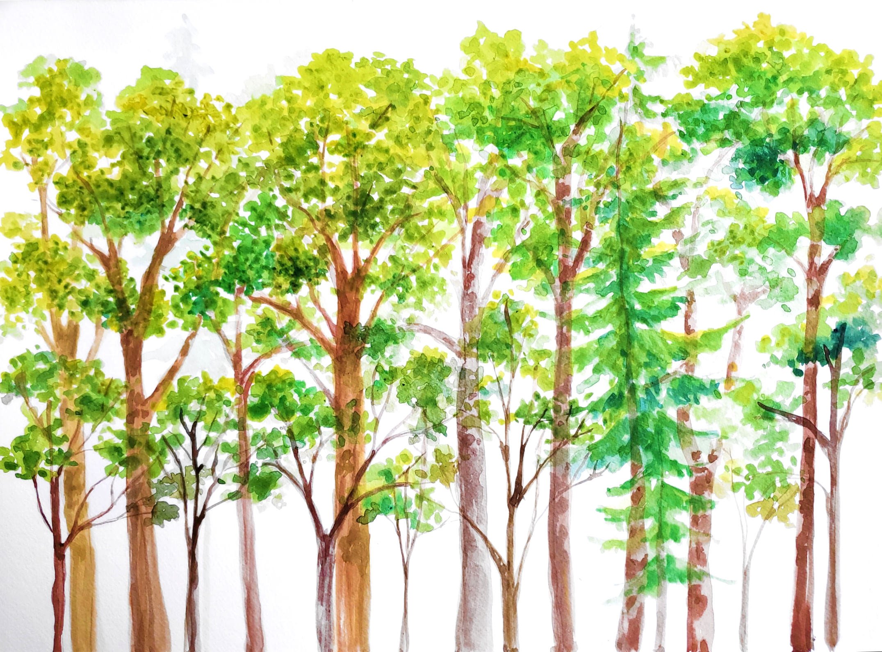

**- T & DROUGHT  
SENSITIVITY OF   
ANNUAL GROWTH (MOST CONDITIONS)  
- CONTRIBUTION TO ECOSYSTEM ET &   
C CYCLING**

**- LMA  
- STOMATAL DENSITY  
- LEAF ANGLE   
- PHOTOPROTECTION  
- ISOPRENE EMISSION\***

**- SOLAR RADIATION   
- WINDSPEED  
- TAIR  
- VPD**

**- STOMATAL CONDUCTANCE,   
 & T SENSITIVITY  
- PHOTOSYNTHESIS   
 - RESPIRATION**

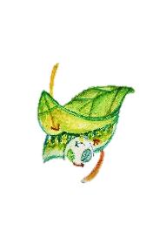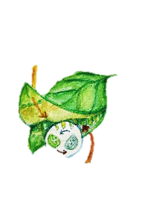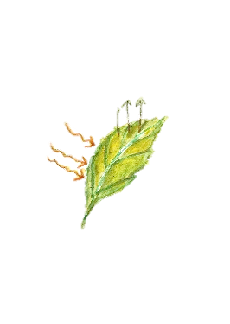

**- TLEAF – TAIR- HEAT DISSIPATION**

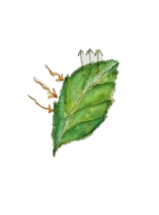

**4. LEAF GAS EXCHANGE**

**5. ECOLOGY**

**3. LEAF TRAITS**

**2. LEAF TEMPERATURE**

**1. BIOPHYSICAL**

**- LEAF SIZE & WIDTH   
- LEAF WATER CONTENT**

**T SENSITIVITY   
OF  
PHOTOSYNTHESIS &  
 RESPIRATION**

**- T SENSITIVITY   
(IN MESIC CONDITIONS)  
OF ANNUAL GROWTH**

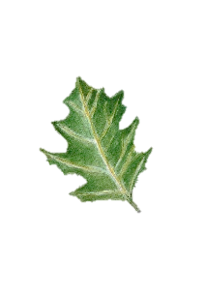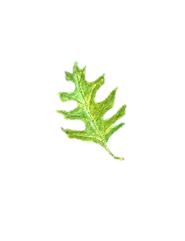

**RELATIVE  
HUMIDITY**